Given an array of integers heights representing the histogram's bar height where the width of each bar is 1, return *the area of the largest rectangle in the histogram*.

**Example 1:**

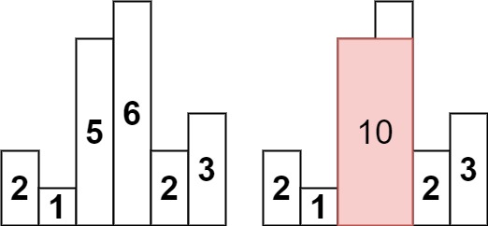

Input: heights = [2,1,5,6,2,3]  
Output: 10  
Explanation: The above is a histogram where width of each bar is 1.  
The largest rectangle is shown in the red area, which has an area = 10 units.

**Example 2:**

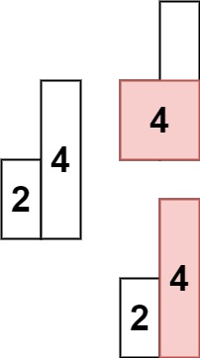

Input: heights = [2,4]  
Output: 4

**Constraints:**

* 1 <= heights.length <= 105
* 0 <= heights[i] <= 104